**Phawngpui Mountain**

Phawngpui, also known as Blue Mountain, is the highest mountain peak in the Mizo Hills and in the state of Mizoram, India, with an elevation of 2157 m. It is in Lawngtlai district, in the southeastern region of Mizoram near the Myanmar border.

Phawngpui is the highest peak of the [Lushai Hills](https://en.wikipedia.org/wiki/Lushai_Hills). There is a semicircular series of [cliffs](https://en.wikipedia.org/wiki/Cliff) on the western side called *Thlazuang Khàm*, which have a sharp and deep fall; [mountain goats](https://en.wikipedia.org/wiki/Mountain_goat) live there. These cliffs are believed to be haunted by spirits. On the peak, there is a level ground of about 2 km2 in area.

Since 1992 the mountain has been included in the [protected area](https://en.wikipedia.org/wiki/Protected_area) of the [Phawngpui National Park](https://en.wikipedia.org/wiki/Phawngpui_National_Park" \o "Phawngpui National Park), one of only two [national parks of India](https://en.wikipedia.org/wiki/National_parks_of_India) in Mizoram.The [Government of Mizoram](https://en.wikipedia.org/wiki/Government_of_Mizoram) allows [ecofriendly](https://en.wikipedia.org/wiki/Ecofriendly" \o "Ecofriendly) visit to the mountain only during November to April.

1st photo:

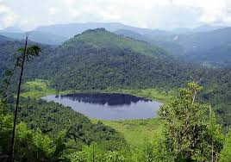

<https://encrypted-tbn0.gstatic.com/images?q=tbn:ANd9GcSXiSLKzPkQlKO6Mcjpq8HFRF2kLEPkAYFNRQ&usqp=CAU>

2nd photo:

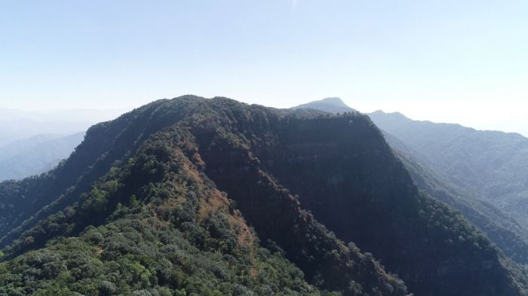

<https://theaizawlpost.org/wp-content/uploads/2021/01/9-6.jpg>